IMPAC 2008 ANNUAL HOLIDAY PARTY

You and your guest are invited for
a Casual Evening of Dining at

La Bove Grande (The Circle Landmark)
(800 Route 70 Lakehurst, NJ 08733)

To be held on Friday, December 5, 2008

From 7:00 PM – 11:00 PM

Please R.S.V.P. to Michelle no later then

Monday, November 24th 2008

via e-mail at msloan@IMPAC1.com or

by phone at 732-408-2525 ext 203.

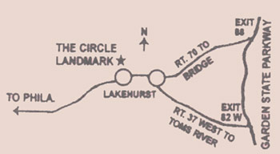
The La Bove Grande-Circle Landmark Restaurant is approximately 4 miles from the IMPAC South office. For directions please visit http://www.circlelandmark.com
or call
(732) 657-8377

